1) Which directional pattern identifies the Hand Yin Primary Channels?
A) They travel from the chest to the hand. +++++
B) They travel from the hand to the head.
C) They travel from the head to the foot.
D) They travel from the foot to the chest.
Feedback: The Hand Yin Primary Channels travel from the chest toward the hand. Why are the other options incorrect? They travel from the hand to the head. — Hand to head is the Hand Yang direction. They travel from the head to the foot. — Head to foot is the Foot Yang direction. They travel from the foot to the chest. — Foot to chest is the Foot Yin direction.
2) Which directional pattern identifies the Hand Yang Primary Channels?
A) Chest to hand
B) Hand to head +++++
C) Head to foot
D) Foot to chest
Feedback: The Hand Yang Primary Channels travel from the hand toward the head. Why are the other options incorrect? Chest to hand — Chest to hand identifies Hand Yin channels. Head to foot — Head to foot identifies Foot Yang channels. Foot to chest — Foot to chest identifies Foot Yin channels.
3) Which directional pattern identifies the Foot Yang Primary Channels?
A) Chest to hand
B) Hand to head
C) Head to foot +++++
D) Foot to chest
Feedback: The Foot Yang Primary Channels descend from the head toward the foot. Why are the other options incorrect? Chest to hand — Chest to hand is the Hand Yin direction. Hand to head — Hand to head is the Hand Yang direction. Foot to chest — Foot to chest is the Foot Yin direction.
4) Which directional pattern identifies the Foot Yin Primary Channels?
A) Chest to hand
B) Hand to head
C) Head to foot
D) Foot to chest +++++
Feedback: The Foot Yin Primary Channels ascend from the foot toward the chest. Why are the other options incorrect? Chest to hand — Chest to hand describes Hand Yin channels. Hand to head — Hand to head describes Hand Yang channels. Head to foot — Head to foot describes Foot Yang channels.
5) What is the anterior-to-posterior order of the three Hand Yin Primary Channels?
A) Heart, Pericardium, Lung
B) Lung, Pericardium, Heart +++++
C) Pericardium, Lung, Heart
D) Lung, Heart, Pericardium
Feedback: On the upper limb, the Hand Yin positional order is Lung anteriorly, Pericardium in the middle and Heart posteriorly. Why are the other options incorrect? Heart, Pericardium, Lung — This reverses the anterior and posterior positions. Pericardium, Lung, Heart — Pericardium is the middle route, not the anterior route. Lung, Heart, Pericardium — Heart is posterior to Pericardium, not in the middle.
6) What is the anterior-to-posterior order of the three Hand Yang Primary Channels?
A) Large Intestine, Sanjiao, Small Intestine +++++
B) Small Intestine, Sanjiao, Large Intestine
C) Sanjiao, Large Intestine, Small Intestine
D) Large Intestine, Small Intestine, Sanjiao
Feedback: The Hand Yang order is Large Intestine anteriorly, Sanjiao in the middle and Small Intestine posteriorly. Why are the other options incorrect? Small Intestine, Sanjiao, Large Intestine — This reverses Large Intestine and Small Intestine. Sanjiao, Large Intestine, Small Intestine — Sanjiao belongs in the middle rather than anteriorly. Large Intestine, Small Intestine, Sanjiao — Small Intestine is posterior, not the middle route.
7) What is the anterior-to-posterior order of the three Foot Yang Primary Channels?
A) Bladder, Gall Bladder, Stomach
B) Stomach, Bladder, Gall Bladder
C) Stomach, Gall Bladder, Bladder +++++
D) Gall Bladder, Stomach, Bladder
Feedback: The Foot Yang order is Stomach anteriorly, Gall Bladder laterally or in the middle and Bladder posteriorly. Why are the other options incorrect? Bladder, Gall Bladder, Stomach — This reverses Stomach and Bladder. Stomach, Bladder, Gall Bladder — Bladder is posterior rather than the middle route. Gall Bladder, Stomach, Bladder — Gall Bladder occupies the middle or lateral position, not the anterior route.
8) What is the anterior-to-posterior order of the three Foot Yin Primary Channels?
A) Kidney, Liver, Spleen
B) Spleen, Liver, Kidney +++++
C) Liver, Spleen, Kidney
D) Spleen, Kidney, Liver
Feedback: The Foot Yin positional map places Spleen anteriorly, Liver in the middle and Kidney posteriorly. Why are the other options incorrect? Kidney, Liver, Spleen — This reverses the anterior and posterior positions. Liver, Spleen, Kidney — Liver belongs in the middle rather than anteriorly. Spleen, Kidney, Liver — Kidney is posterior, not the middle route.
9) What is the channel shown in the image?
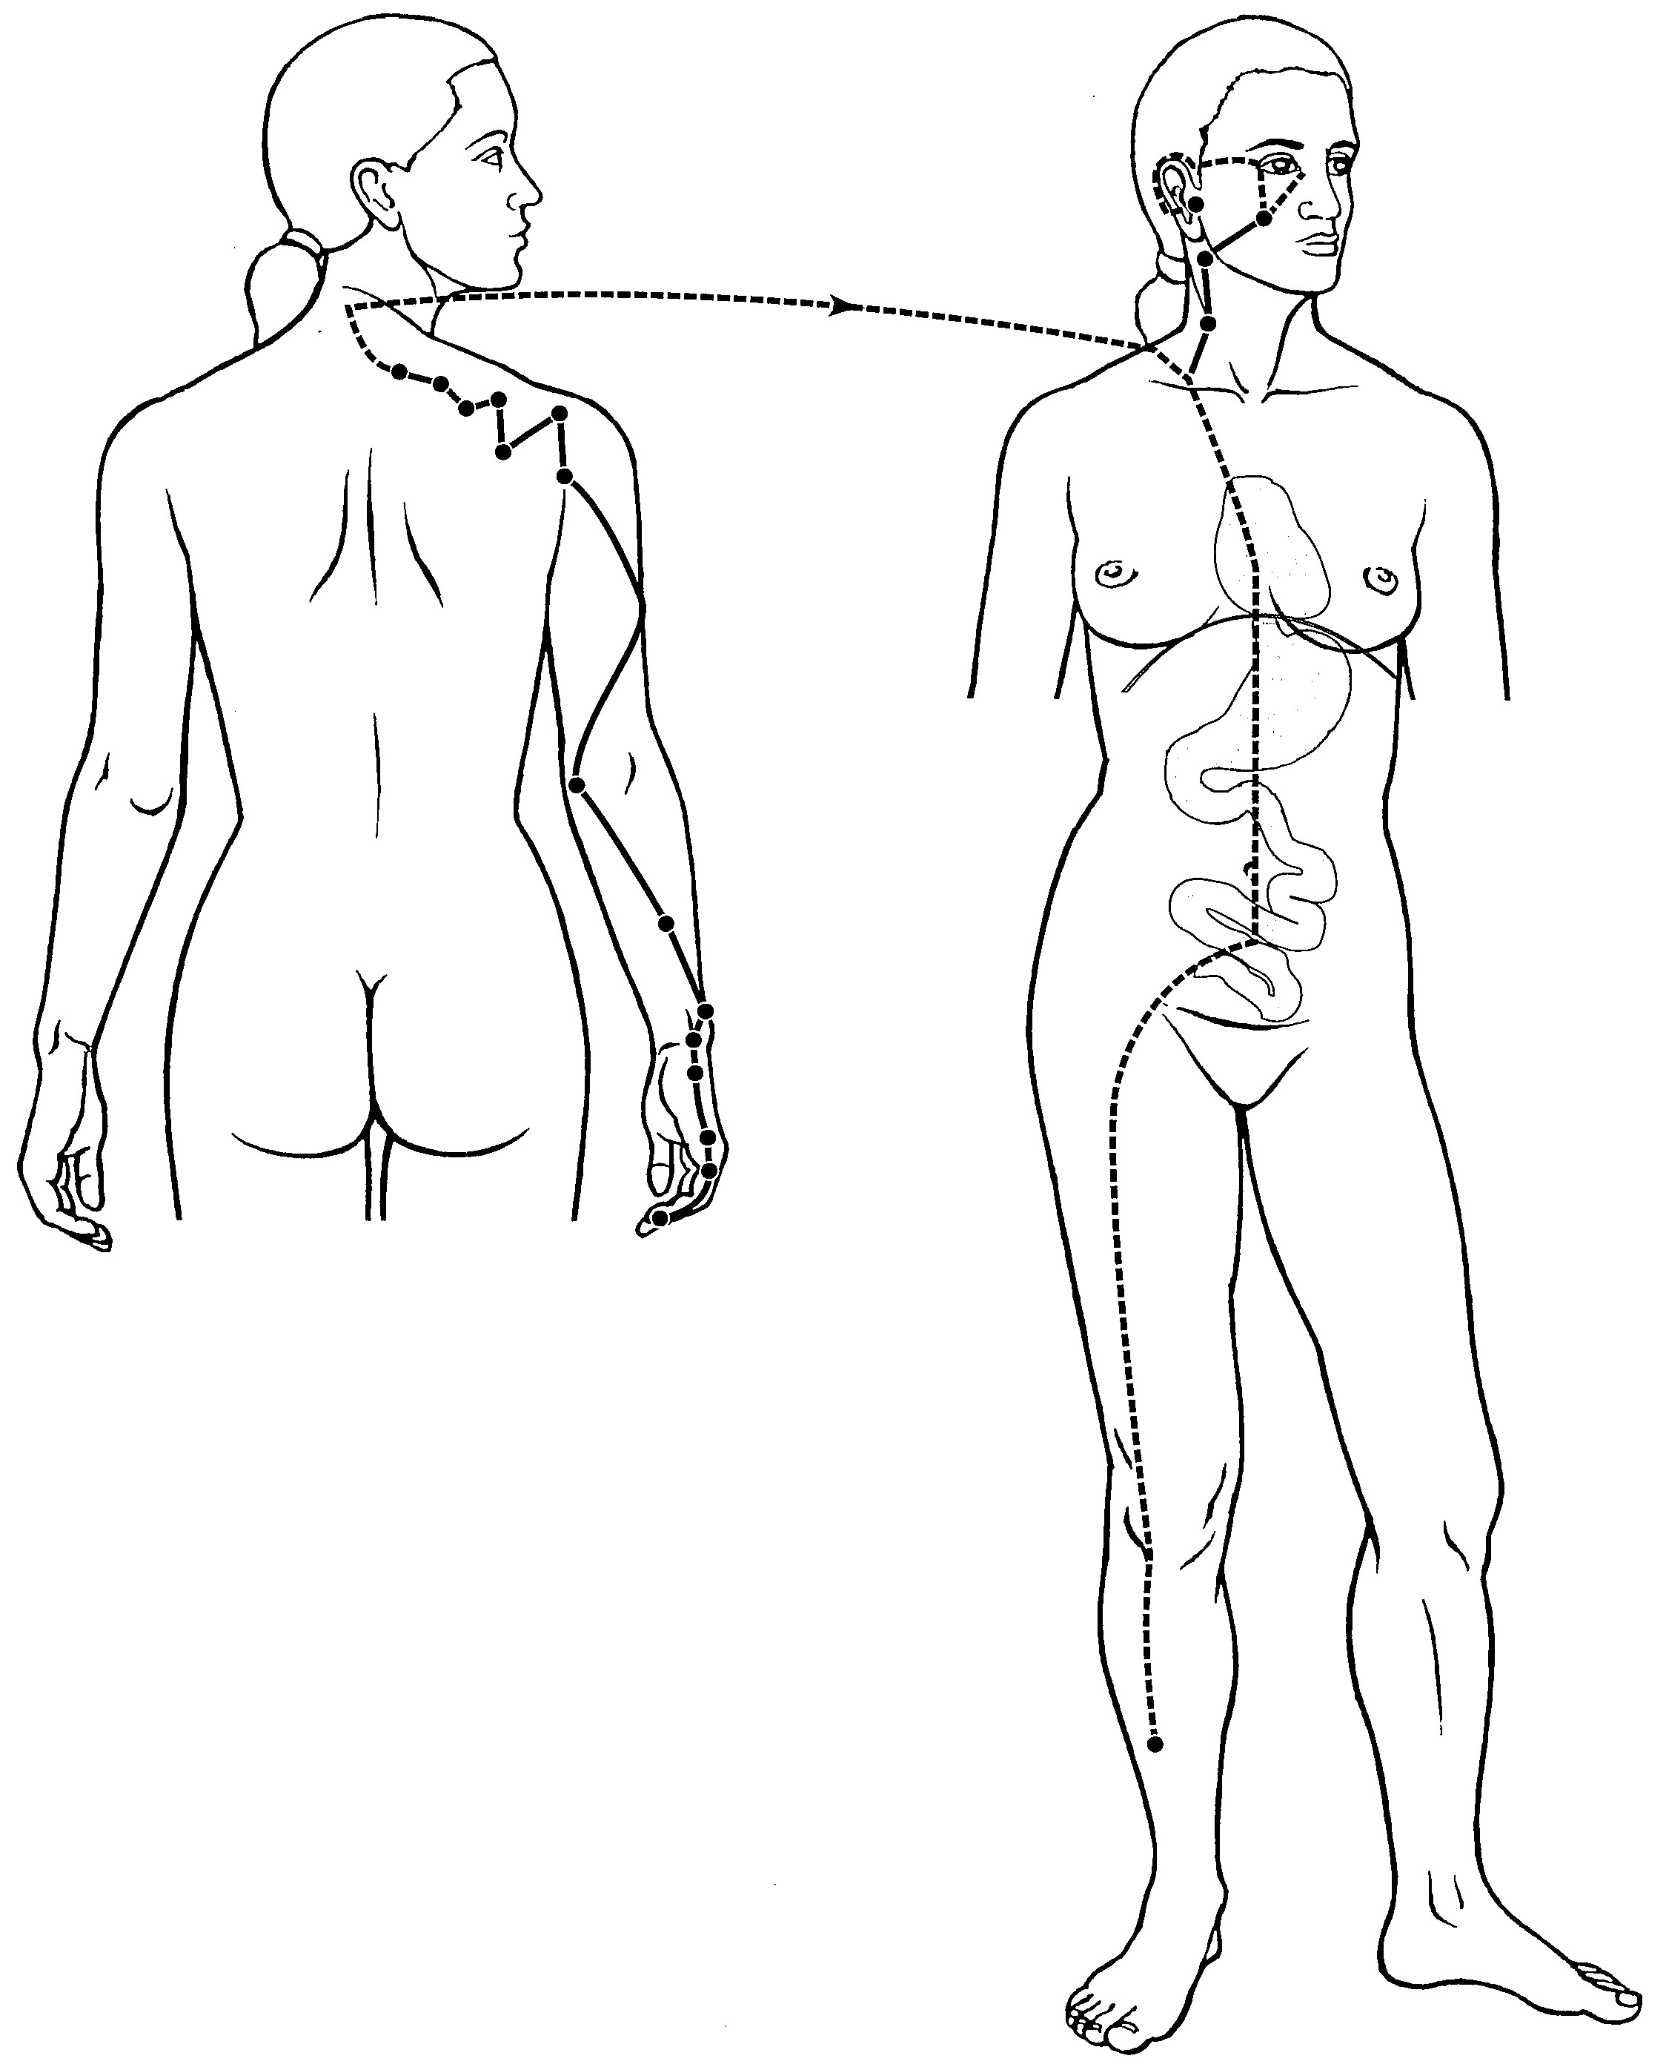
A) Small Intestine Primary Channel +++++
B) Small Intestine Sinew Channel
C) Small Intestine Divergent Channel
D) Small Intestine Luo-Connecting Channel
Feedback: The Small Intestine Primary Channel is identified by its point-bearing route from the little finger through the posterior arm and scapular region toward the face and ear. Its internal branch enters the Heart, crosses the diaphragm, reaches the Stomach and belongs to the Small Intestine. Why are the other options incorrect? Small Intestine Sinew Channel — The Sinew pathway is a broad superficial musculotendinous route with binding regions. Small Intestine Divergent Channel — The Divergent pathway is identified by deep entry and convergence with the paired Heart pathway. Small Intestine Luo-Connecting Channel — The Luo-Connecting pathway begins at SI-7 and has a more limited connecting course.
10) What is the channel shown in the image?
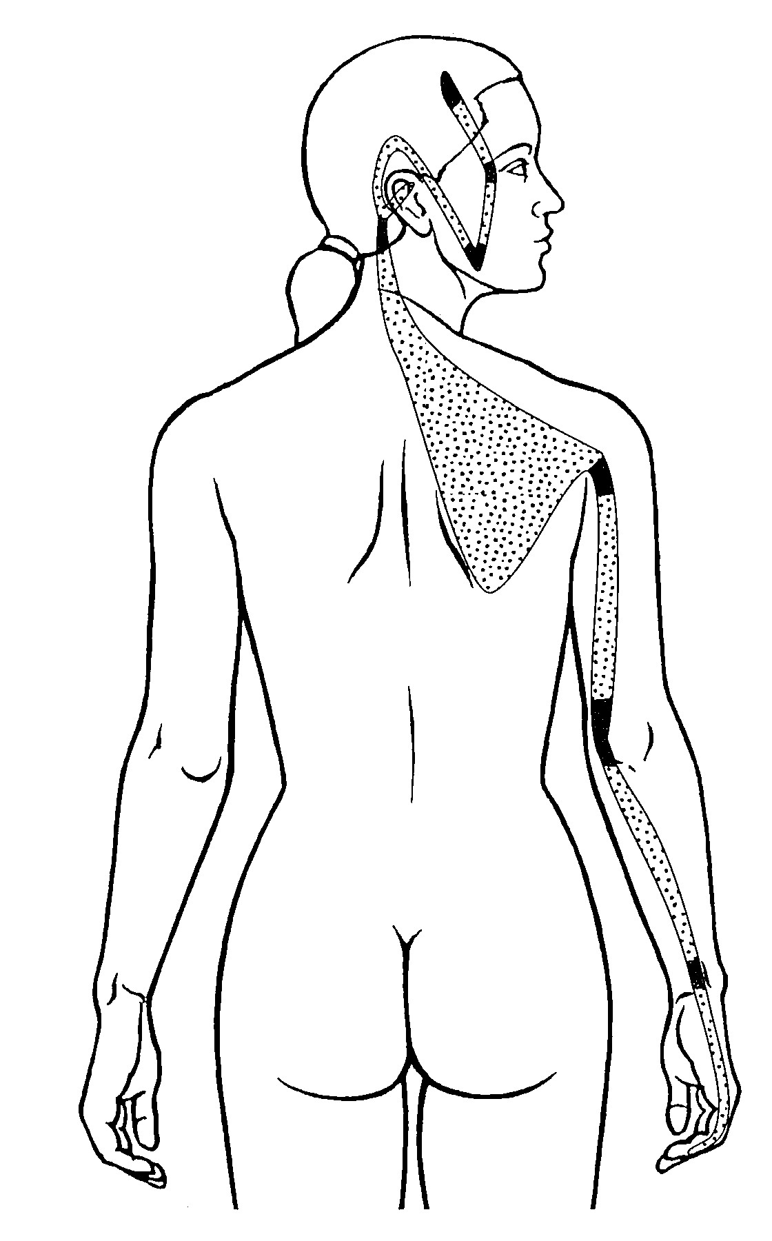
A) Small Intestine Primary Channel
B) Small Intestine Sinew Channel +++++
C) Small Intestine Divergent Channel
D) Small Intestine Luo-Connecting Channel
Feedback: The Small Intestine Sinew Channel is identified by its superficial musculotendinous route from the little finger along the posterior forearm and upper arm, with binding at the wrist and elbow, continuation across the scapular region and ascent through the neck toward the ear, jaw and outer eye. It does not enter the zangfu organs. Why are the other options incorrect? Small Intestine Primary Channel — The Primary Channel is a point-bearing reference route extending from the little finger toward the face and ear. Small Intestine Divergent Channel — The Divergent Channel follows a deep internal paired-channel course. Small Intestine Luo-Connecting Channel — The Luo-Connecting Channel begins at SI-7 and does not form this broad tendon pathway.

